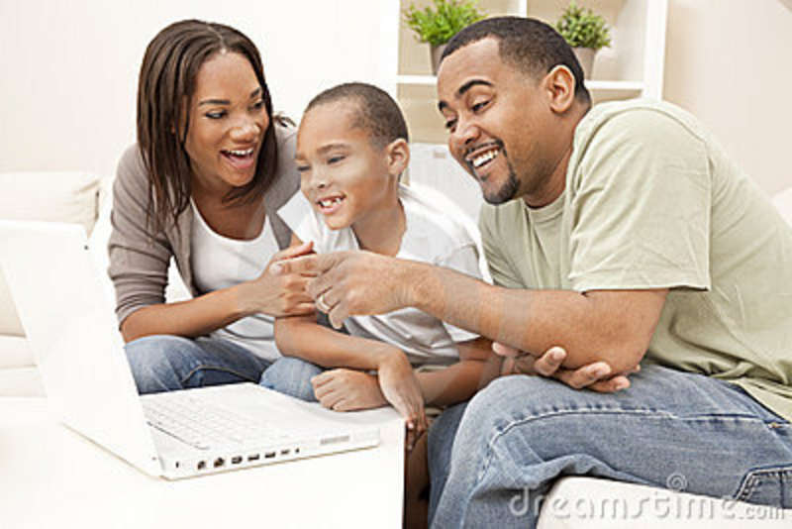**This is a family activity. When someone introduces a new web resource or app that they would like to use, the family should sit down and review the ability to be safe, responsible and respectful on the resource.**

Evaluating New Media

Resources

Name of the Resource:**_______________________________________________________________________**

**Questions to consider for the person introducing the resource**

**How did you learn about the resource?**

**Why do you want an account?**

**How do your friends use this resource?**

**Being Safe**

 I will set up a private account (if not, then I will not use the resource) with the strongest privacy options.

I have read the privacy agreement with my parent/caregiver.

I will set up an account with my parents or caregiver so that you do not give out personal or location information?– such as full name, date of birth, address, phone number, or photos.

*I will only post photos/videos that I have permission to post from _______________________.*

 I will ONLY share my login passwords only with my family member or caregiver.

 If anyone makes me feel pressured or uncomfortable, or acts inappropriately toward me online, I’ll stop talking to that person and will tell _________________________I trust about it.

_____________________________________________________________________________________

**Being Respectful and Responsible**

Top of Form

I will not bully, humiliate, or upset anyone online or with my phone – whether through sharing photos, videos, or screenshots, spreading rumors or gossip, or setting up fake profiles – and I will stand up to those who do.



*Bottom of Form*

*I understand that if I am disrespectful that I will have to, apologize in person to the person that I harmed and I will lose my account privileges for __________________ time.*

I know that whatever I share online or with my cell phone can spread fast and far. I will not post anything online that could harm my reputation.

Whenever I use, reference, or share someone else’s creative work online, I will give proper credit to the author or artist.

I know that not everything I read, hear, or see online is true. I will consider whether a source or author is credible.

_____________________________________________________________________________________

X______________________________________

Signed by Caregiver

X______________________________________

Signed by Me